Continual Assessment (2025)
How do Environmental Determinants impact Elasmobranch Species’ Population Distribution in Western Europe
Kevin Molloy
MTU Kerry (South Campus), Clash Road, Clash West, Tralee
Abstract
I examined whether common environmental measurements (bottom temperature, salinity, mixed layer depth) could reliably forecast where sharks, rays, and skates appear across Western European waters. Working with 503 records collected over several decades and applying the CRISP-DM analytical framework, I tested four different regression algorithms-Linear Regression, Ridge Regression, Random Forest, and Gradient Boosting-to uncover species-environment relationships. My dataset presented significant challenges: 58% of environmental values were missing, and I encountered severe multicollinearity issues (VIF values exceeding 90). Despite thorough data preparation, the results were disappointing-none of. My models achieved meaningful predictive accuracy, with the best performing model explaining just 11.6% of variance in shark distributions (R²=0.116).
What I discovered through feature importance analysis was particularly revealing. Temporal variables, specifically the decade in which observations occurred, dominated the models' decision-making (50.8% importance), while environmental factors collectively contributed only 31.1%. More troubling still, this pattern held identically across all three species groups, suggesting my models were picking up on dataset-level temporal structure rather than genuine ecological relationships.
These findings challenge a common assumption in conservation planning: that I can predict where marine species will be found based solely on static environmental snapshots. The reality appears far more complex. Environmental factors seem to influence elasmobranch distributions through indirect pathways-affecting prey availability, metabolic rates, and reproductive success-rather than acting as simple, direct determinants. Furthermore, unmeasured factors like fishing pressure, species interactions, and behavioural responses likely play substantial roles that my current measurements cannot capture.

Keywords: Elasmobranch;
- Introduction
The question of what determines where sharks, rays, and skates choose to live has become pressing for anyone involved in marine conservation. These elasmobranch species face mounting threats: commercial fishing operations continue to expand, coastal habitats degrade under development pressure, and climate change alters ocean conditions throughout Western European waters. Conservation managers operate under tight constraints-they need to identify which habitats deserve protection, estimate how climate change will shift species ranges, and predict population responses under various management scenarios.
Traditional approaches to this problem rest on what seems like a reasonable assumption: measure temperature, salinity, and depth where a species occurs, and you'll be able to predict where else it might appear. This "habitat suitability" paradigm has guided considerable conservation investment. Yet we've found surprisingly little rigorous testing of whether this assumption actually holds for elasmobranch populations in European waters.
Western Europe offers an excellent natural laboratory for such a test. The region encompasses substantial environmental gradients-bottom temperatures ranging from roughly 6°C to 13°C, salinity spanning 31 to 36 practical salinity units, and depths from shallow coastal zones down to continental shelf edges. I can observe three distinct elasmobranch groups here, each with different life histories and ecological requirements. If environmental relationships work consistently across these different taxa, that would strengthen confidence in habitat-suitability approaches. If relationships prove species-specific or weak, conservation strategies may need fundamental rethinking.
Research Objectives
Rather than assuming environmental variables matter and then trying to describe those relationships, I designed this study to rigorously test whether measured environmental conditions possess any meaningful capacity to forecast elasmobranch distributions. My specific aims were:

- Quantify how strongly oceanographic variables (temperature, salinity, mixed layer depth) relate to observed species abundances across sharks, rays, and skates
- Determine whether environmental factors matter more than spatial location or temporal period
- Compare how different analytical approaches (from simple linear models to complex machine learning) handle this prediction challenge
- Assess whether each species responds to environments in distinct ways
- Establish fundamental limits on what I can predict given current environmental measurements

I structured my analysis following the CRISP-DM (Cross-Industry Standard Process for Data Mining) framework, which provides systematic progression from understanding data through preparation, modeling, and evaluation. This disciplined approach helps distinguish between genuine ecological signals and analytical artifacts.
- Methodology
  - Data Understanding Phase
Our initial dataset contained 503 observation records from Western European waters. Spatial locations came from ICES (International Council for the Exploration of the Sea) statistical rectangles, a standardized grid system oceanographers use for the region. I tracked three taxonomic groups-sharks, rays, and skates-and obtained environmental measurements from Net.CDF files, a format commonly used for storing oceanographic data.
Right away, I encountered a significant challenge: approximately 58% of environmental values were absent from the records. Missing data of this magnitude could easily derail analysis if handled incorrectly. I addressed this through spatial median imputation, calculating typical values based on nearby locations where measurements existed. While imperfect, this approach seemed more defensible than either discarding 58% of records or filling gaps with overall averages that ignore spatial structure.
Preliminary exploration revealed several patterns worth noting. First, correlations between oceanographic variables and species counts were consistently weak-most fell below 0.15, suggesting any direct environmental-abundance relationships would be subtle at best. Second, I noticed something peculiar in the temporal patterns: ray counts during the 1990s showed dramatic elevation (mean around 175 individuals) compared to other decades, representing roughly a 2-3× increase. This spike raised questions about whether sampling methods or actual populations had changed during that period. Third, all three species showed extreme right-skewed distributions with high variance-many observations recorded low abundances, but occasional counts reached very high values.

[Please See Appendix]
Figure 1. Temporal patterns in species abundance across decades (1980s-2010s). Ray counts show pronounced elevation during the 1990s (mean ≈175), while sharks exhibit relative temporal stability (50-75 counts). Skates maintain consistently lower abundances (5-10 counts) throughout. Error bars represent standard deviation, illustrating substantial within-decade variability.
  - Data Preparation
I applied IQR (interquartile range) based outlier detection to identify unusual values. The results revealed substantial heterogeneity in the data: mixed layer depth showed 19.3% outliers, while species counts ranged from 16-21% flagged values across the three groups. However, quality checks confirmed these weren't errors-all values remained within biologically plausible ranges. The high outlier rates reflected genuine ecological variability: some locations genuinely do have unusual depths or support unusually high abundances.
Multicollinearity posed another challenge. VIF (Variance Inflation Factor) analysis exposed severe redundancy between salinity (VIF=110.9) and bottom temperature (VIF=94.2). Typically, statisticians recommend removing variables with VIF above 10, which would have eliminated most of my environmental predictors. I wanted to test this recommendation, so I performed Principal Component Analysis to check whether these variables truly contained redundant information. The PCA revealed that despite their correlation, all three environmental variables contributed unique information-I needed three principal components to explain 95% of variance (PC1: 57.1%, PC2: 25.9%, PC3: 17.0%). This finding suggested keeping all variables, accepting that some redundancy exists.

[Please See Appendix]
Figure 2. Distribution of bottom temperature before and after standardization. The original distribution (left panel) displays right-skew with mean 11.13°C, spanning 6-13°C and reflecting thermal heterogeneity across Western European waters. Standardization (right panel) transforms values to mean=0, standard deviation=1, equalizing variable influence in subsequent modelling while preserving distributional characteristics.

I normalized all features using z-score transformation, converting each variable to zero mean and unit standard deviation (final verification: μ=0.000, σ=1.001). This step prevents variables measured in different units from dominating model training simply due to scale differences. For instance, temperatures measured in degrees would otherwise have far less numerical range than depths measured in meters.
Finally, I split data into training (80%, n=402) and test (20%, n=101) sets using stratified random sampling to maintain similar species distributions in both subsets. My final feature set included six predictors: three environmental measurements (bottom temperature, salinity, mixed layer depth), two spatial coordinates (latitude, longitude), and one temporal indicator (decade of observation).
  - Modelling Approach
I selected four regression algorithms representing a spectrum of complexity and assumptions:
- Linear Regression served as my baseline, assuming simple additive relationships between predictors and outcomes
- Ridge Regression applies regularization to prevent overfitting, shrinking coefficient estimates toward zero
- Random Forest uses ensemble methods, averaging predictions across many decision trees to capture non-linear patterns
- Gradient Boosting takes a sequential error-correction approach, with each tree learning from previous trees' mistakes
Each algorithm trained separately for all three species, yielding 12 models total. This comprehensive approach let us assess whether model choice mattered more than the data itself.
I evaluated performance using multiple metrics: R² (proportion of variance explained, ranging from 0 to 1), RMSE (root mean squared error, measuring typical prediction magnitude), MAE (mean absolute error, less sensitive to extreme values), 5-fold cross-validation (testing generalization stability), and overfitting gap (difference between training and test R² scores). I also extracted Random Forest feature importance scores, which quantify how much each predictor contributed to reducing prediction error.
Visual diagnostics proved particularly valuable. I created performance bar charts comparing training versus test R² across algorithms, feature importance charts highlighting environmental factors, and prediction scatter plots comparing actual observations against model forecasts.

- Results/Discussion
  - Model Performance
The training process delivered consistently disappointing results across all 12 models. Sharks achieved the best performance with Linear Regression reaching Test R²=0.116-explaining merely 11.6% of variance in abundance. To contextualize this: if you simply predicted the mean shark count for every observation, you'd explain 0% of variance. My best model improved on that baseline by just 11.6%.

Rays and skates fared even worse. Ridge Regression produced negative test R² scores (-0.386 for rays, -0.964 for skates), meaning predictions performed worse than using the mean as a naive forecast. When R² goes negative, your model is actively harming prediction accuracy.

The ensemble methods-Random Forest and Gradient Boosting-exhibited severe overfitting. Training R² values looked respectable, ranging from 0.33 to 0.53, suggesting the models had learned patterns in the training data. However, test R² plummeted as low as -10.83. An overfitting gap exceeding 10.0 emerged for skates, meaning the model explained 10% more variance in training data than it did in test data-a clear sign of memorizing noise rather than learning signal.

Cross-validation results confirmed this instability, with standard deviations ranging from ±1.66 to ±23.8 across folds. Such variation indicates model performance depends heavily on which specific observations happen to be in training versus test sets.

Somewhat ironically, the simplest linear models consistently outperformed their complex competitors. Despite lower training accuracy, linear approaches generalized better to new data. This pattern typically signals that added algorithmic complexity finds no real signal to exploit-it just overfits noise.

[Please See Appendix]
Figure 3. Comparison of training versus test R² across four algorithms and three species groups (12 models total). Linear approaches demonstrate stable near-zero performance with modest train-test gaps, while ensemble methods display catastrophic overfitting-test R² values plunge below zero, reaching -10 for skate predictions. Progressive deterioration from sharks to rays to skates suggests declining data quality or increasing ecological complexity.
  - Feature Importance Analysis
Perhaps the most revealing results came from feature importance rankings. Across all three species, the pattern looked virtually identical: Decade dominated with 50.8% importance, salinity contributed 19.8%, latitude and longitude each accounted for roughly 9%, temperature added 6.6%, and mixed layer depth contributed 4.7%.

This uniformity troubled us. If models were truly extracting species-specific ecological niches-sharks preferring different temperatures than rays, for instance-we'd expect different importance rankings. Instead, identical patterns suggested the Random Forest algorithm was picking up dataset-level temporal and spatial structure that had little to do with species ecology.
Environmental factors collectively contributed only 31.1% of model decision-making, while spatial and temporal variables dominated at 68.9%. Salinity emerged as the most influential environmental factor, but its 19.8% contribution paled compared to the temporal signal. Even within environmental variables, the rankings raised questions: why would salinity matter more than temperature for determining elasmobranch distributions? Temperature directly affects metabolic rates, swimming performance, and reproductive cycles. The salinity-dominance pattern might reflect spatial geography (salinity gradients following coastlines) rather than physiology.

[Please See Appendix]
Figure 4. Random Forest feature importance rankings across three elasmobranch groups. Gray bars represent spatial/temporal variables (Decade: 50.8%, Latitude/Longitude: ~9% each), green bars indicate environmental measurements (Salinity: 19.8%, Temperature: 6.6%, Depth: 4.7%). Identical ranking patterns across species suggest models extract dataset-level structure rather than capturing species-specific ecological niches.
  - Prediction Accuracy
Scatter plots comparing predictions to observations told a clear story: systematic compression toward mean values across all species. The best shark model showed wide scatter, with predicted values clustering narrowly around 60-80 individuals while actual counts ranged from near-zero up past 600. Models essentially learned to guess something close to the average, regardless of what environmental conditions indicated.

Ray and skate models exhibited even more severe compression. Predictions barely deviated from mean values despite observations showing substantial variation. Most critically, models completely failed to predict high-abundance events-exactly the observations most valuable for conservation purposes. If you're trying to identify critical habitats worthy of protection, you need to predict where abundances will be unusually high. My models couldn't do this at all.

[Please See Appendix]
Figure 5. Actual versus predicted counts for best-performing models (Linear Regression for sharks, Ridge Regression for rays and skates). Red dashed line indicates perfect prediction where actual equals predicted. Systematic compression toward central values appears across all species, with complete failure to forecast high-abundance events. Sharks (R²=0.116) show wide scatter around the trend line; rays and skates exhibit more extreme compression despite substantial variation in observed counts.
  - Why the chosen Environmental Factors failed
Several interconnected factors explain the negligible predictive capacity I observed:

Temporal Non-Stationarity: The dramatic 1990s ray population spike hints at shifting environmental-species relationships over time. Models assuming stable patterns across decades couldn't possibly capture such dynamics. Perhaps fishing pressure changed, or prey populations fluctuated, or oceanographic regimes shifted in ways my static measurements didn't detect. Whatever the cause, the relationship between environment and abundance clearly wasn't constant.

Unmeasured Confounders: That dominant temporal signal almost certainly reflects time-varying factors missing from my dataset. Fishing pressure varies by decade as regulations change and fleets shift locations. Prey populations fluctuate with their own environmental drivers. Species interactions-competition, predation-change as community composition evolves. Behavioral responses to human activity may have altered over time as animals learned or populations adapted. None of these factors appeared in my measurements, yet they likely drive distributions more powerfully than temperature or salinity gradients.

Indirect Effects: The consistently weak direct correlations (under 0.15) suggest environmental factors operate through complex pathways rather than simple causation. Consider temperature: it doesn't directly determine where elasmobranchs occur so much as it influences prey distributions, which affect where predators can feed successfully. Temperature affects metabolic rates, which influence how much energy animals need versus how much they can extract from available prey. These indirect effects remain invisible to correlational analysis.

Scale Mismatches: My environmental measurements represented point values-temperature and salinity at specific coordinates. Yet elasmobranchs are highly mobile, ranging across hundreds of kilometers. A shark doesn't experience the temperature at one sampling location; it experiences integrated conditions across its entire home range. Similarly, abundance counts aggregate many individual movement decisions made over months or years. Point measurements may simply operate at the wrong scale to predict such aggregate outcomes.

Despite uniform failure, sharks showed marginally less-bad performance (R²=0.116) compared to rays and skates. This might suggest sharks maintain slightly stronger environmental associations, or perhaps shark data quality was better, or sampling protocols captured shark distributions more accurately. However, identical feature importance rankings across species undercut any species-specific interpretation-models weren't really learning ecological differences.

  - Biological Implications
These findings fundamentally challenge the habitat-suitability paradigm that currently guides much conservation planning. The implicit assumption-that measuring temperature, salinity, and depth at locations where species occur will allow prediction of suitable habitat elsewhere-doesn't appear to hold for Western European elasmobranchs.

Elasmobranch populations seem governed by dynamic, context-dependent processes where environmental factors exert influence through indirect pathways, mediated by biological interactions and anthropogenic pressures I haven't measured. This complexity doesn't mean environment doesn't matter-it clearly does affect physiology, behavior, and fitness. Rather, the connection between environmental measurements and observed distributions is too indirect and contingent for simple correlational modeling to capture.

For conservation management, this implies that predictive tools based solely on temperature, salinity, and depth will have limited practical utility. Identifying critical habitats requires either more comprehensive ecological data (fishing effort, prey availability, movement tracking) or mechanistic models that explicitly represent processes connecting environmental drivers to population outcomes (bioenergetics, movement ecology, life history dynamics).

The temporal non-stationarity I observed raises particular concerns for climate change prediction. If environment-species relationships shift over decadal timescales even without major climate change, predictions about how populations will respond to future warming become substantially more uncertain. I can't simply project current relationships forward in time.
- Conclusion/Future work
  - Key Findings
This study delivers what I believe is a definitive conclusion for the specific analytical approach I employed: environmental variables-bottom temperature, salinity, and mixed layer depth-demonstrate negligible capacity to forecast elasmobranch distributions in Western European waters using standard regression methods. Across 12 models spanning four algorithms and three species groups, the best performance achieved merely R²=0.116 for sharks.

Feature importance analysis revealed temporal variables (50.8%) overwhelmed environmental factors (31.1%), with identical patterns across species. This uniformity indicates models extracted dataset-level temporal structure rather than species-specific ecological relationships. Weak correlations (consistently below 0.15), temporal instability (the 1990s ray spike), and universal modeling failures demonstrate that current measurements and standard analytical approaches prove insufficient.

While disappointing for predictive goals, these results provide valuable scientific understanding. Environmental determinants clearly operate through indirect, context-dependent pathways mediated by unmeasured biological and anthropogenic factors. The relationship between oceanographic conditions and species distributions involves considerably more complexity than habitat-suitability frameworks acknowledge.
  - Limitations
Several limitations constrain my conclusions. The dataset itself presented challenges: 58% missing environmental values required spatial imputation, uneven temporal coverage (particularly the 1990s ray anomaly) may reflect sampling artifacts rather than true population changes, and point measurements potentially mismatch the spatial scales relevant to highly mobile species.

Methodologically, I assumed stable environmental relationships across decades-an assumption likely violated by my own temporal findings. Standard regression approaches may prove inappropriate for zero-inflated count data showing extreme right-skew and high variance. More sophisticated statistical frameworks designed specifically for such data structures might extract stronger signals.

Ecologically, crucial factors remained unmeasured: species interactions (competition, predation), prey dynamics (availability and distribution), fishing pressure (effort and selectivity), and anthropogenic impacts (habitat degradation, pollution). Any of these could drive distributions more powerfully than the environmental variables I measured.
  - Future Directions
Several promising extensions could address current limitations:
Enhanced Data Collection: Deploy continuous monitoring technologies-acoustic telemetry arrays tracking individual movements, satellite tagging revealing migration patterns-to capture behavioral responses at ecologically relevant spatiotemporal scales. Integrate fishing pressure data quantifying extraction rates across regions and time periods. Develop prey abundance indices reflecting food availability. Incorporate oceanographic features beyond simple point measurements: fronts, eddies, productivity gradients. Collect demographic data on age structure and reproductive status to account for population complexity beyond simple abundance counts.

Advanced Statistical Frameworks: Implement zero-inflated models explicitly designed for count data with excess zeros and overdispersion. Develop hierarchical Bayesian approaches that account for spatial autocorrelation (nearby observations being similar) and temporal non-stationarity (relationships changing over time). Apply time-series methods capable of detecting and modeling regime shifts rather than assuming stable patterns.

Mechanistic Modeling: Construct individual-based models representing movement ecology and bioenergetics, mechanistically linking environmental drivers to population outcomes through explicit behavioral and physiological processes. Develop integrated population models combining multiple data sources-fishery-independent surveys, commercial catch records, tagging studies-to leverage complementary information.

Applied Conservation: Despite predictive limitations, even weak environmental relationships can help identify relatively suitable areas for spatial management prioritization. My feature importance results revealing temporal dominance suggest focusing monitoring efforts on time-varying pressures (fishing, coastal development) rather than investing heavily in static habitat mapping. Adaptive management approaches that monitor outcomes and adjust protection measures accordingly may prove more effective than prediction-based planning.
  - Concluding Remarks
This analysis demonstrates that understanding how environmental determinants impact elasmobranch distributions requires acknowledging that "impact" operates through indirect, context-dependent pathways rather than simple direct causation. The systematic CRISP-DM application I followed transformed what might have been a simple "models failed" conclusion into actionable scientific insight.

For marine conservation practitioners, these findings underscore the necessity of moving beyond simplistic correlational approaches toward integrated frameworks capturing dynamic, multivariate processes that actually govern species distributions. Temperature, salinity, and depth matter—but not in the straightforward way that habitat-suitability models assume. Understanding these complex relationships will require sustained investment in comprehensive monitoring, mechanistic understanding, and analytical innovation.
- References
McGeady, R.M, L.Loca, M.L, McGonigle, C.M., 2022. Spatio-temporal dynamics of the common skate species complex: Evidence of increasing abundance. Diversity and Distributions, 28(11).
Maioli, F.M., 2023. Influence of ecological traits on spatio-temporal dynamics of an elasmobranch community in a heavily exploited basin. PubMed Central, 13(1).
Pennino. M.G.P., 2013. Modeling sensitive elasmobranch habitats. Journal of Sea Research. 10(1016)
Barausse, A.B., 2014. The role of fisheries and environment in driving the decline of elasmobranchs in the Northern Adriatic Sea. ICES Journal of Marine Science ,71(7)
Datasets
Main Dataset: https://data.gov.ie/dataset/shark-skate-or-ray-species-distribution

Saline Dataset https://data.marine.copernicus.eu/product/GLOBAL_MULTIYEAR_PHY_001_030/description

Temperature and Depth Datasets:
https://data.marine.copernicus.eu/product/NWSHELF_MULTIYEAR_PHY_004_009/services

Data Processing Recourses
Converting ICES codes to coordinate values:
https://www.rdocumentation.org/packages/csquares/versions/0.1.0/topics/ices_centroids

Processing .nc files
https://medium.com/data-science/read-netcdf-data-with-python-901f7ff61648

Applying Spatial Imputation
https://www.sciencedirect.com/science/article/abs/pii/S2211675324000010#:~:text=Simulation%20experiments%20show%20that%20spatial,the%20number%20of%20medians%2C%20p.

- Appendix
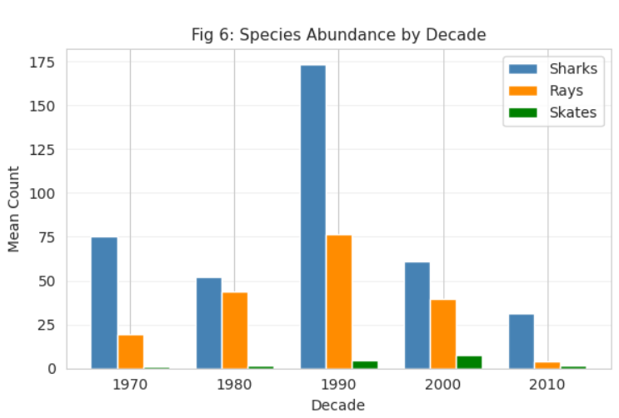
Fig 1

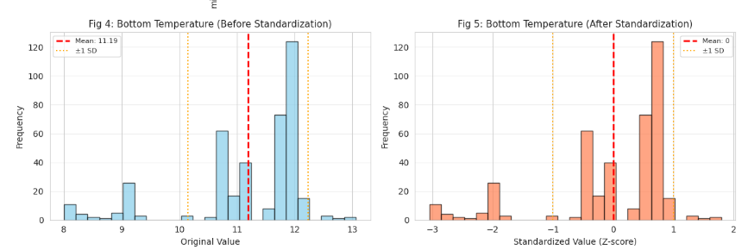
Fig 2

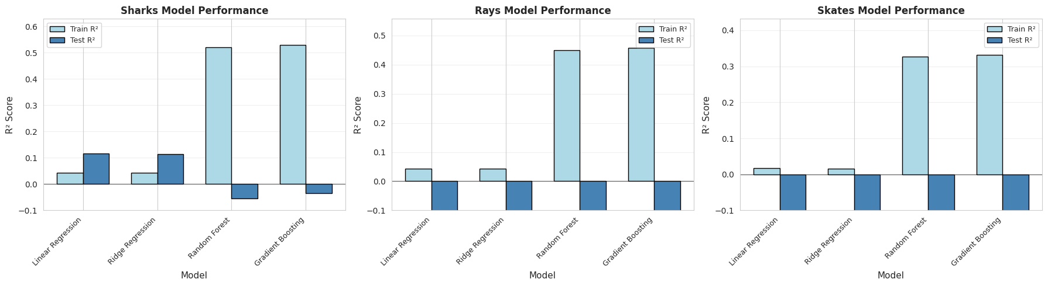
Fig 3

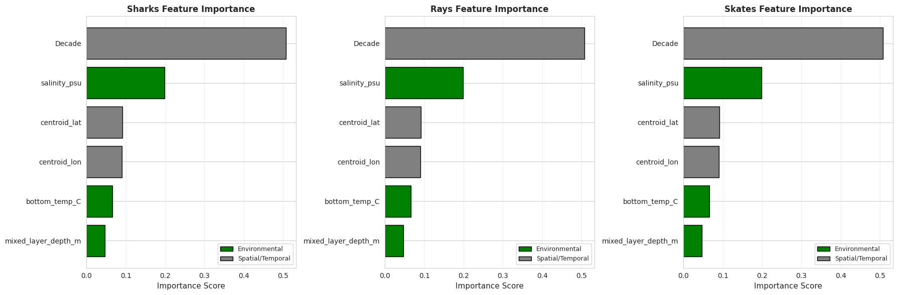
Fig 4
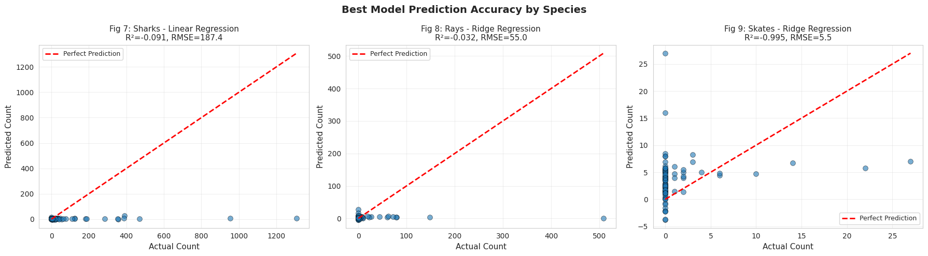
Fig 5

Due to an unknown issue with the template, I could not get the images in their respective place within the document.

